Github link : https://github.com/raosahil04/Eval-1

1.  
def check_strings(s1, s2):

s1_lower = s1.lower()

s2_lower = s2.lower()

common_chars = []

uncommon_chars_s1 = []

uncommon_chars_s2 = []

set_s1 = set(s1_lower)

set_s2 = set(s2_lower)

common_chars_set = set_s1.intersection(set_s2)

for char in s1:

if char.lower() in common_chars_set:

common_chars.append(char)

for char in s1:

if char.lower() not in common_chars_set:

uncommon_chars_s1.append(char)

for char in s2:

if char.lower() not in common_chars_set:

uncommon_chars_s2.append(char)

if ''.join(common_chars).lower() == s1_lower:

print("Yes")

print("String1:", ''.join(common_chars))

print("String2:", ''.join(uncommon_chars_s2))

else:

print("No")

print("Test Case 1:")

check_strings("Refer", "Rafael")

print("\nTest Case 2:")

check_strings("Refer", "Regfree")

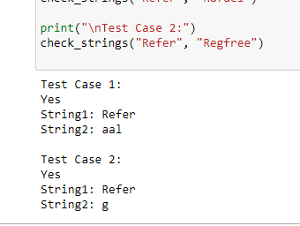

2.  
def reverse_words_in_string(s):

words = s.split()

reversed_words = [word[::-1] for word in words]

reversed_string = ' '.join(reversed_words)

return reversed_string

sample_input = "ViDeo SurVeiLLance SyStems"

print("Input:", sample_input)

print("Output:", reverse_words_in_string(sample_input))

